Polarizability derivatives from dipole derivatives - program polderdip.f

Contents
Background
Usage
Option file
Theory
Origin dependence
Single resonance state limit
Static Derivatives
Visualization

Background
Raman and ROA intensities can be calculated based on three polarizabilities,
$α_{\text{αβ}}=\frac{1}{ℏ}\sum_{e}{μ_{0e,α}μ_{0e,β}}f(ω_{e0},ω,ω')$, (1)
$G_{\text{αβ}}=\frac{1}{ℏ}\sum_{e}{μ_{0e,α}m_{e0,β}}g(ω_{e0},ω,ω')$, (2)
$A_{α,\text{βγ}}=\frac{1}{ℏ}\sum_{e}{μ_{0e,α}Θ_{e0,β}}f(ω_{e0},ω,ω')$, (3)
where $f(ω_{e0},ω,ω')=\left(\frac{1}{ω_{e0}−ω+iΓ}+\frac{1}{ω_{e0}+ω'+iΓ}\right)$, $g(ω_{e0},ω,ω')=\left(\frac{1}{ω_{e0}−ω+iΓ}−\frac{1}{ω_{e0}+ω'+iΓ}\right)$,
$μ_{0e,α}=⟨0|μ_{α}|e⟩$, $m_{e0,β}=⟨e|m_{β}|0⟩$, $Θ_{e0,β}=⟨e|Θ_{β}|0⟩$,
ħ is the reduced Planck’s constant, μ, m and Θ are the electric dipole, magnetic dipole, and electric quadrupole moment operators, respectively, 0 and e denote the ground and excited electronic states, ω_{e0} is the difference of their angular frequencies, ω and ω’ are the excitation and scattered frequencies, $i=\sqrt{−1}$, Γ is an arbitrary bandwidth.
Polarizability derivatives with respect to the α-coordinate of nucleus λ are calculated as
$\frac{∂α_{\text{αβ}}}{∂R_{ε}^{λ}}=\frac{1}{ℏ}\sum_{e}{\frac{∂(μ_{0e,α}μ_{0e,β})}{∂R_{ε}^{λ}}}f+\frac{1}{ℏ}\sum_{e}{μ_{0e,α}μ_{0e,β}}\frac{∂f}{∂R_{ε}^{λ}}=α_{\text{αβ},\text{λε}}^{(d)}+α_{\text{αβ},\text{λε}}^{(g)}$ (4)
$\frac{∂G_{\text{αβ}}}{∂R_{ε}^{λ}}=\frac{1}{ℏ}\sum_{e}{\frac{∂(μ_{0e,α}m_{0e,β})}{∂R_{ε}^{λ}}}g+\frac{1}{ℏ}\sum_{e}{μ_{0e,α}m_{0e,β}}\frac{∂g}{∂R_{ε}^{λ}}=G_{\text{αβ},\text{λε}}^{(d)}+G_{\text{αβ},\text{λε}}^{(g)}$ (5)
$\frac{∂A_{α,\text{βγ}}}{∂R_{ε}^{λ}}=\frac{1}{ℏ}\sum_{e}{\frac{∂(μ_{0e,α}Θ_{0e,\text{βγ}})}{∂R_{ε}^{λ}}}f+\frac{1}{ℏ}\sum_{e}{μ_{0e,α}Θ_{0e,\text{βγ}}}\frac{∂f}{∂R_{ε}^{λ}}=A_{\text{αβ},\text{λε}}^{(d)}+A_{\text{αβ},\text{λε}}^{(g)}$ (6)
where the “dipole” (d) and “gradient” (g) parts can be calculated separately.

Usage
1) Make an input prototype, for example INP:

%chk=h2oer.chk
%mem=1gb
%nproc=8
#p b3lyp/6-31G** td=(singlets,nstates=#STATE,root=#STATE)
nosymm freq

h2o

0 1
1 2.951485 1.025917 0.000000
8 2.219032 1.459858 0.455623
1 2.642901 1.889704 1.209248

Do not forget the "#p" ("IOp(99/33=1)" for more than 100 atoms) so that " Electronic Transition Derivatives" are listed in the output.

2) make inputs and run Gaussian for as many states as you want, e.g. run this script:
for i in {1..79}
do
sed s/#STATE/$i/g INP > $i.inp
g16 $i.inp
done

3) List the outputs in TD.LST: ls *.log > TD.LST

4) (optional) if you want to use static polarizabilities as well, calculate polarizability derivatives at a static limit, e.g. with
... freq=roa ...
...
5000nm
in Gaussian input, put them to STATIC.TTT

5) Run polderdip
It produces FILE.TTT, (FILEW.TTT) POL.TTT, A.TTT and GP.TTT.
Also aG.prn, b2.prn, bG.prn, bA.prn frequency-dependent invariants.

Options (defaults) variable, in POLDERDIP.OPT:

ADAPT (f) adapt to every fundamental transition (normal mode, F.INP required)
ladapt
RDAPT (1) if ladapt, use ω_{e}’ = ω_{e} + radapt × ω_{I} for each normal mode I
radapt
WIDTH (0) Γ in cm⁻¹
width
EXCNM (532) ω in nm
excnm
INTERVAL (F) calculate polar. derivatives in an interval of excitation frequencies
lint evmin...evmax with np points, put them to FILEW.TTT
ESCALE (f) scale electronic parameters
escale
EVMIN (4) lowest excitation energy, in eV
evmin
EVMAX (9) highest excitation energy, in eV
evmax
FILEG (CP.TTT) coupled-perturbed polarizability derivative file name
fgg
GROUND (GROUND.OUT) file with the ground state gradient
fgr
GSWITCH (f) G’ second in FILE.TTT
gswitch
LGROUND (f) use ground state energy gradient
lgr
LDDEG (f) ignore degenerate transitions
lddeg
NMLIN (f) scan of frequencies linear in wavelength
lnm
NPOINTS (500) number of excitation energies
evmax
LDOG (t) distributed origin gauge for G
ldog
STATIC (F) use the static derivatives from STATIC.TTT
lstat
SEPARATE (F) calculate separate contributions from each transition
lsep
USEDD (t) use dipole derivatives
usedd
USEGR (t) use energy gradients
usegr
WDEGL (100 cm-1 limit for the degeneration
wdeg

Get all exc profile - use programs new6w.f and tabprnf.f
e.g.
for i in {1..100}
do
echo $i
new6w 1 $i
tabprnf ROA.TAB 3 3901 100 4000 l 300 10
mv S.PRN ram.$i.prn
tabprnf ROA.TAB 8 3901 100 4000 l 300 10
mv S.PRN roa.$i.prn
done

escale:
File ESC.LST must be present,
with new wavelength (nm), dipole and rotational strength (debye²) on one line for each electronic transition

FILE.TTT:
In FILE.TTT the tensors are organized so that after index integers the first three columns (1-3) of real numbers are for real and the other three (4-6) for imaginary part of the tensors α,G’,A. By default, G is an exception; it is purely imaginary but also put into columns 1-3. Since α, A are real, only 3 columns thus need to be populated. Schematically,
Re(α) Re(α) Re(α) Im(α) Im(α) Im(α)
Im(G) Im(G) Im(G) Re(G) Re(G) Re(G)
Re(A) Re(A) Re(A) Im(A) Im(A) Im(A)
As the developers’ version of Gaussian (J. Cheeseman) introduces complex bandwidth which generates imaginary parts of α and A and a real part of G, it makes more sense to write it consistently, i.e.
Re(α) Re(α) Re(α) Im(α) Im(α) Im(α)
Re(G) Re(G) Re(G) Im(G) Im(G) Im(G)
Re(A) Re(A) Re(A) Im(A) Im(A) Im(A)
This is requested by the GSWITCH option. Such arrangement is for backward compatibility: to combine the tensors with default processing of old Gaussian use the first format, Gaussian with complex bandwidth needs the second one.

Theory

Origin dependence

Here, we use for simplicity the atomic units. Realizing that $⟨0|∇_{α}|e⟩=ω_{e0}⟨0|r_{α}|e⟩$ we introduce a velocity form of α, $α_{\text{αβ}}^{v}=−2\sum_{e}{\frac{⟨0|r_{α}|e⟩⟨e|∇_{β}|0⟩}{ω_{e0}^{2}−ω^{2}}}$. Only for exact wavefunctions, $α_{\text{αβ}}=α_{\text{αβ}}^{v}$. The velocity form is needed if we investigate G-derivatives in common origin at 0 and a shift vector T. Derivatives of α are origin independent, $\frac{∂α_{\text{αβ}}}{∂R_{ε}^{λ}}(0)=\frac{∂α_{\text{αβ}}}{∂R_{ε}^{λ}}(T)$. However, for G,
$\frac{∂G_{\text{αβ}}}{∂R_{ε}^{λ}}(\text{COM},0)=\frac{∂G_{\text{αβ}}}{∂R_{ε}^{λ}}(\text{COM},T)+\frac{ω}{2}ε_{\text{βγδ}}T_{γ}\frac{∂α_{\text{αδ}}^{v}}{∂R_{ε}^{λ}}$,. The ROA invariants $\frac{∂α_{\text{αβ}}}{∂R_{ε}^{λ}}\frac{∂G_{\text{αβ}}(\text{COM})}{∂R_{μ}^{λ}}$ and $\frac{∂α_{\text{αα}}}{∂R_{ε}^{λ}}\frac{∂G_{\text{ββ}}(\text{COM})}{∂R_{μ}^{λ}}$ are thus also origin-dependent.
Therefore, we define G in so called distributed origin gauge as

$\frac{∂G_{\text{αβ}}}{∂R_{ε}^{λ}}(\text{DOG})=\frac{∂G_{\text{αβ}}}{∂R_{ε}^{λ}}(\text{COM})+\frac{ω}{2}ε_{\text{βγδ}}R_{γ}^{0λ}\frac{∂(α_{\text{αδ}}−α_{\text{αδ}}^{v})}{∂R_{ε}^{λ}}$, where R^{0λ} is the equilibrium nuclear position.
Under an origin shift T we get

$\frac{∂G_{\text{αβ}}}{∂R_{ε}^{λ}}(\text{DOG},0)=\frac{∂G_{\text{αβ}}}{∂R_{ε}^{λ}}(\text{DOG},T)+\frac{ω}{2}ε_{\text{βγδ}}T_{γ}\frac{∂α_{\text{αδ}}}{∂R_{ε}^{λ}}$,
and from that we can find that the ROA invariants $\frac{∂α_{\text{αβ}}}{∂R_{ε}^{λ}}\frac{∂G_{\text{αβ}}(\text{DOG})}{∂R_{μ}^{λ}}$ and $\frac{∂α_{\text{αα}}}{∂R_{ε}^{λ}}\frac{∂G_{\text{ββ}}(\text{DOG})}{∂R_{μ}^{λ}}$ are origin-independent.

Single resonance state limit
In resonance ($ω_{e0}=ω$) only the last term in the derivative expressions survives. For simplicity, we also choose a coordinate where the transition dipole moment goes along the z axis and introduce the dipole and rotational strengths, $D=\text{Re}⟨0|μ_{z}|e⟩⟨e|μ_{z}|0⟩$, $R=\text{Im}⟨0|μ_{z}|e⟩⟨e|m_{z}|0⟩$. Then for the derivatives we get $\frac{∂G_{\text{αβ}}}{∂R}=\frac{2}{ℏ}\frac{ω_{e0}^{2}}{Γ^{2}ω_{e0}^{2}}R\frac{∂ω_{e0}}{∂R}$ and $\frac{∂α_{\text{αβ}}}{∂R}=−\frac{2}{ℏ}\frac{ω_{e0}^{2}}{ω_{e0}^{2}Γ^{2}}D\frac{∂ω_{e0}}{∂R_{n}}$ .

Then the SCP backscattering ROA and Raman intensity in the harmonic approximation is
$$I_{\text{ROA}}=−\frac{\text{16}K}{v}α_{\text{zz}}G_{\text{zz}}=−\frac{\text{16}K}{v}\text{RD}{\left(\frac{2}{ℏ}\frac{ω_{e0}^{2}}{ω_{e0}^{2}Γ^{2}}\frac{∂ω_{e0}}{∂Q}\right)}^{2}$$
$$I_{\text{Ram}}=8{Kα}_{\text{zz}}α_{\text{zz}}=8{\text{KD}}^{2}{\left(\frac{2}{ℏ}\frac{ω_{e0}^{2}}{ω_{e0}^{2}Γ^{2}}\frac{∂ω_{e0}}{∂Q}\right)}^{2}$$
where K is a constant, Q the normal mode of interest, and v is velocity of light. Finally, the circular intensity difference becomes $\text{CID}=\frac{I_{\text{ROA}}}{I_{\text{Ram}}}=−\frac{2R}{\text{vD}}=−\frac{g}{2}$, where g is the dissymmetry factor.

Static Derivatives

From the limited number of excited states, we calculate the “resonance” part of α (and other tensors), the total polarizability is $α(ω)=α_{\text{RES}}(ω)+α_{\text{NR}}(ω)$. We can suppose that $α_{\text{RES}}$ quickly diminishes for ω→0, but $α_{\text{NR}}$ originating in a big number of molecular states is almost frequency-independent. Then we can calculate $α(ω_{0})$ for a small excitation frequency (e.g. freq=roa for ω₀ = 5000 nm) and calculate
$α(ω)≃α_{\text{RES}}(ω)+α(ω_{0})−α_{\text{RES}}(ω_{0})$.
DCPII
$\begin{aligned}\text{DCPII}=8[\text{45}αG+β_{s}(G)^{2}+5β_{a}(G)^{2}−β_{s}(A)^{2}−β_{a}(A)^{2} \\ +\text{45}αG+β_{s}(G)^{2}+5β_{a}(G)^{2}+β_{s}(A)^{2}−β_{a}(A)^{2}]\end{aligned}$ ... J. Chem. Theory Comput. 2018, 14, 6370−6390

$αG=\frac{1}{9}\text{Im}[α_{\text{αα}}^{s}(G_{\text{ββ}}^{s})^{}]$, $αG=\frac{1}{9}\text{Im}[α_{\text{αα}}^{s}(G_{\text{ββ}}^{s})^{}]$
$β_{s}(G)^{2}=\frac{1}{2}\text{Im}[3α_{\text{αβ}}^{s}(G_{\text{αβ}}^{s})^{}−α_{\text{αα}}^{s}(G_{\text{ββ}}^{s})^{}]$, $β_{s}(G)^{2}=\frac{1}{2}\text{Im}[3α_{\text{αβ}}^{s}(G_{\text{αβ}}^{s})^{}−α_{\text{αα}}^{s}(G_{\text{ββ}}^{s})^{}]$
$β_{a}(G)^{2}=\frac{9}{2}\text{Im}[α_{\text{αβ}}^{a}(G_{\text{αβ}}^{a})^{}]$, $β_{a}(G)^{2}=\frac{9}{2}\text{Im}[α_{\text{αβ}}^{a}(G_{\text{αβ}}^{a})^{}]$
$$α_{\text{αβ}}=\frac{1}{ℏ}\sum_{m≠i,f}{\left(\frac{⟨f|μ_{α}|m⟩⟨m|μ_{β}|i⟩}{ω_{\text{mi}}−ω+iΓ}+\frac{⟨f|μ_{β}|m⟩⟨m|μ_{α}|i⟩}{ω_{\text{mi}}+ω+iΓ}\right)}$$
$$G_{\text{αβ}}=\frac{1}{ℏ}\sum_{m≠i,f}{\left(\frac{⟨f|μ_{α}|m⟩⟨m|m_{β}|i⟩}{ω_{\text{mi}}−ω+iΓ}+\frac{⟨f|m_{β}|m⟩⟨m|μ_{α}|i⟩}{ω_{\text{mi}}+ω+iΓ}\right)}$$
$$G_{\text{αβ}}=\frac{1}{ℏ}\sum_{m≠i,f}{\left(\frac{⟨f|m_{α}|m⟩⟨m|μ_{β}|i⟩}{ω_{\text{mi}}−ω+iΓ}+\frac{⟨f|μ_{β}|m⟩⟨m|m_{α}|i⟩}{ω_{\text{mi}}+ω+iΓ}\right)}$$
Resonance/el model
$$\begin{aligned}G_{\text{αβ}}+G_{\text{αβ}}+G_{\text{βα}}+G_{\text{βα}} \\ \frac{1}{ℏ}\sum_{m≠i,f}{\left(\frac{⟨f|μ_{α}|m⟩⟨m|m_{β}|i⟩+⟨f|m_{α}|m⟩⟨m|μ_{β}|i⟩+⟨f|μ_{β}|m⟩⟨m|m_{α}|i⟩+⟨f|m_{β}|m⟩⟨m|μ_{α}|i⟩}{ω_{\text{mi}}−ω+iΓ}\right)}\end{aligned}$$

$$=\frac{1}{ℏ}\sum_{m≠i,f}{}$$
$$=\frac{1}{ℏ}\sum_{m≠i,f}{}$$
only FC:
$$=0$$
(BO:)
$$=\frac{1}{ℏ}⟨f_{v}|\sum_{e≠0}{\left(\frac{⟨0|μ_{α}|e⟩⟨e|m_{β}|0⟩+⟨0|m_{α}|e⟩⟨e|μ_{β}|0⟩+⟨0|μ_{β}|e⟩⟨e|m_{α}|0⟩+⟨0|m_{β}|e⟩⟨e|μ_{α}|0⟩}{ω_{\text{mi}}−ω+iΓ}\right)}|i_{v}⟩$$
$$=0$$
Electronic model
$$α_{\text{αβ}}\text{\sim }⟨f_{v}|\frac{1}{ℏ}\frac{⟨0|μ_{α}|e⟩⟨e|μ_{β}|0⟩}{ω_{e0}−ω+iΓ}|i_{v}⟩=α_{\text{βα}}$$
$$G_{\text{αβ}}\text{\sim }⟨f_{v}|\frac{1}{ℏ}\frac{⟨0|μ_{α}|e⟩⟨e|m_{β}|0⟩}{ω_{e0}−ω+iΓ}|i_{v}⟩$$
$$G_{\text{αβ}}^{s}\text{\sim }\frac{1}{2ℏ}\frac{(⟨0|μ_{α}|e⟩⟨e|m_{β}|0⟩+⟨0|μ_{β}|e⟩⟨e|m_{α}|0⟩)}{ω_{e0}−ω+iΓ}$$
$$α_{\text{αβ}}G_{\text{αβ}}^{}\text{\sim }−\frac{1}{ℏ^{2}}\frac{⟨f|μ_{α}|m⟩⟨m|μ_{β}|i⟩⟨f|μ_{α}|m⟩⟨m|m_{β}|i⟩}{(ω_{\text{mi}}−ω)^{2}+Γ^{2}}$$
$$β_{s}(G)^{2}=\frac{1}{2}\text{Im}[3α_{\text{αβ}}^{s}(G_{\text{αβ}}^{s})^{}−α_{\text{αα}}^{s}(G_{\text{ββ}}^{s})^{}]=\frac{1}{2}\text{Im}[3α_{\text{αβ}}^{s}(G_{\text{αβ}}^{s})^{}]−\frac{9}{2}αG$$
$$β_{a}(G)^{2}=0$$
$$α_{\text{αβ}}^{a}=0$$

Adaptation for each mode frequency ω_{I}

By default, ladapt = .false. and ω = ω’ in 1-6. With ladapt = .true. we consider the electronic frequency adapted to each fundamental transition (normal mode) I , $ω_{e}→ω_{e,I}=ω_{e}+\text{radapt}×ω_{I}$ and use the scattered frequency ω_{I}’ = ω - ω_{I}, where radapt is a parameter, typically within (-1,1). This is implemented for the dipolar parts only, e.g.,
$$α_{\text{αβ},\text{λε}}^{(d)}(I)=\frac{1}{ℏ}\sum_{e}{\frac{∂(μ_{0e,α}μ_{0e,β})}{∂R_{ε}^{λ}}}f(ω_{e,I},ω_{I},ω_{I}')$$
so that normal mode polarizability derivatives are calculated as
$\frac{∂α_{\text{αβ}}^{(d)}}{∂Q_{I}}=\sum_{λ,ε}{S_{I,\text{λε}}α_{\text{αβ},\text{λε}}^{(d)}(I)}$ where S is the Cartesian-normal mode transformation matrix.
The idea behind this is to correct for a systematic error caused by the BO approximation.

Idea II (not yet developed): without the vibronic resolution and the resonance excitation frequency is the electronic one, ω_{e}. In reality, a higher frequency mode (J in the Figure) may have the effective resonance frequency little bit bigger than a lower-frequency one (I) because for J in the excited electronic state (e) vibrational states providing biggest overlaps with the initial and final vibrational states of electronic ground state (0) have on average higher frequencies. Hence we can try to adapt the electronic excitation frequency to each mode.
ω
0
e
ω_{e0}
ω_{I}
ω_{J}
ω_{e,J}
ω_{e,I}
effective
overlaps

Visualization

Commercial program (e.g. Matlab) or waterfal (Pascal for Windows).
sorder.f sorts the spectra, example
(make spectra:)
for i in {1..100}
do
echo $i
new6w 1 $i
tabprnf ROA.TAB 3 3901 100 4000 l 300 10
mv S.PRN ram.$i.prn
tabprnf ROA.TAB 8 3901 100 4000 l 300 10
mv S.PRN roa.$i.prn
done
(collect spectra:)
ls ram.prn > SLIST.TXT
(in vi check the order in SLIST.TXT)
sorder
mv SLIST.PRN sram.prn
ls roa.prn > SLIST.TXT
(in vi check the order in SLIST.TXT)
sorder
mv SLIST.PRN sroa.prn

sram.prn and sroa.prn are readable by waterfall, with xev.prn or xnm.prn scales crated by polderdip

Example, Raman and ROA:
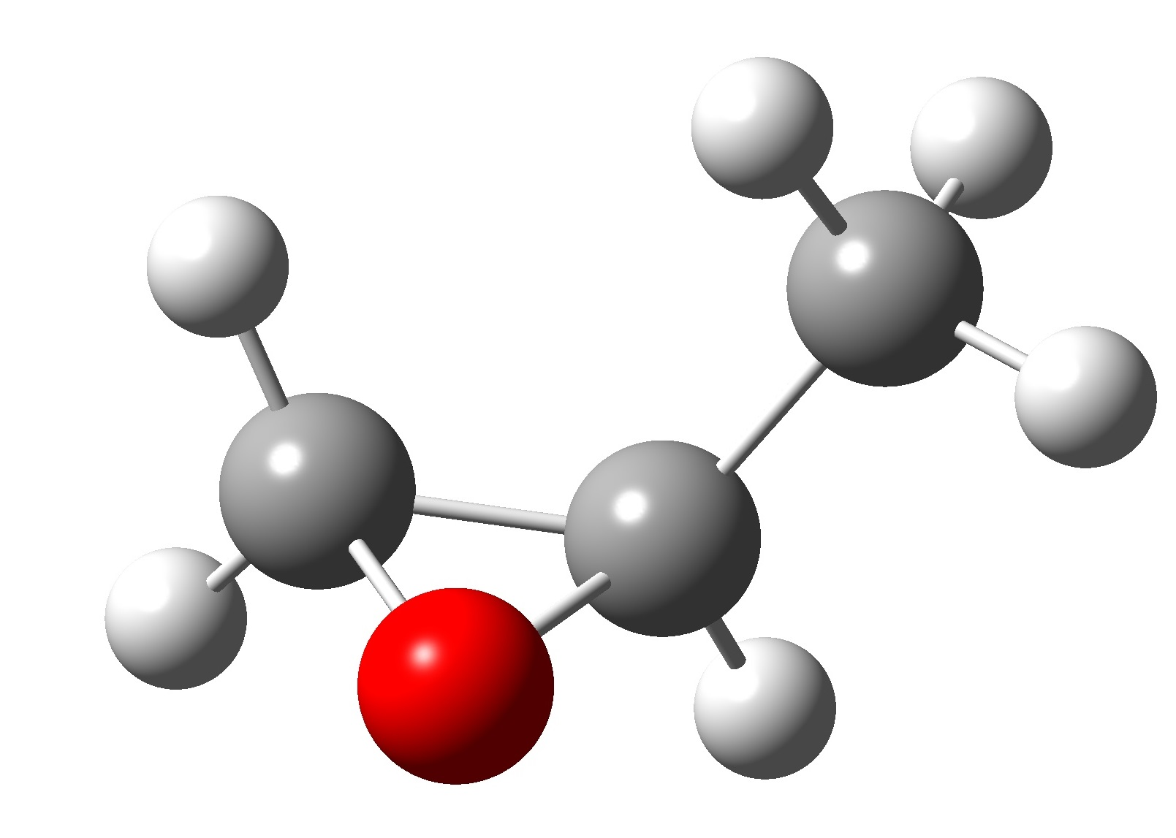
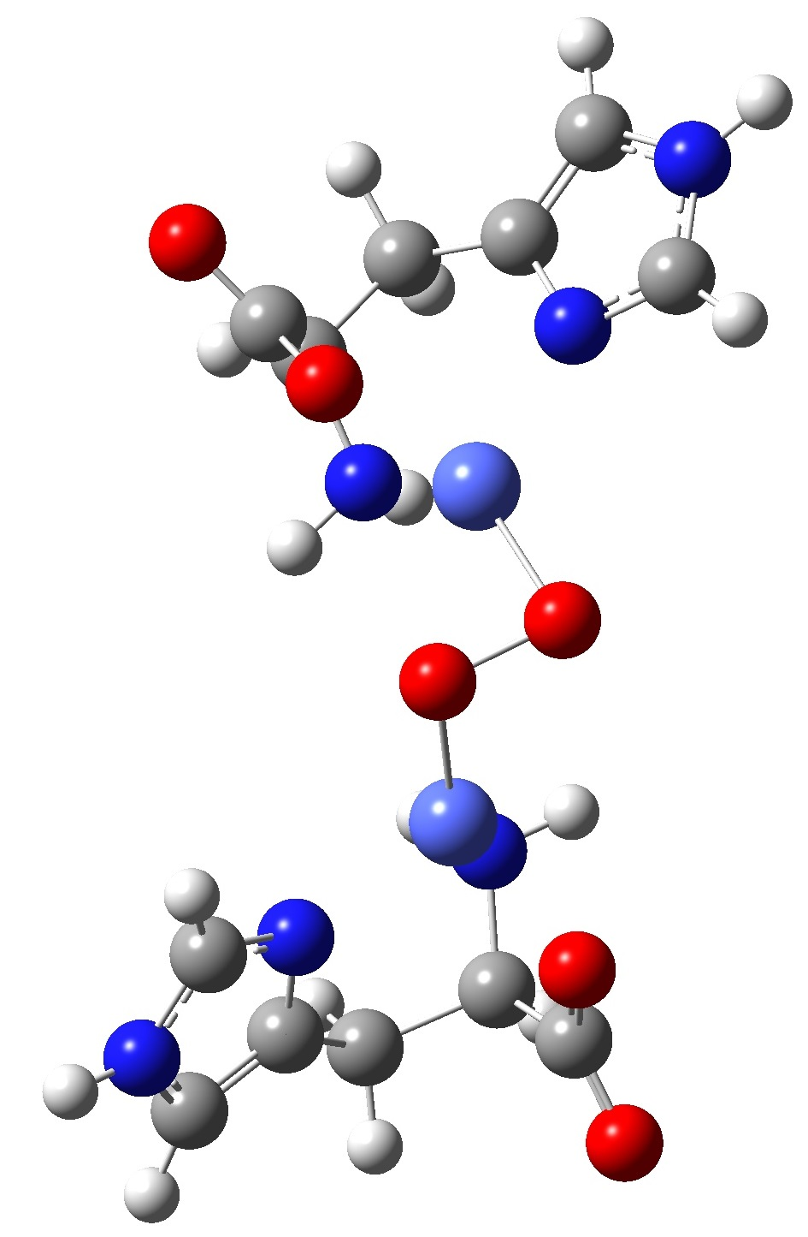
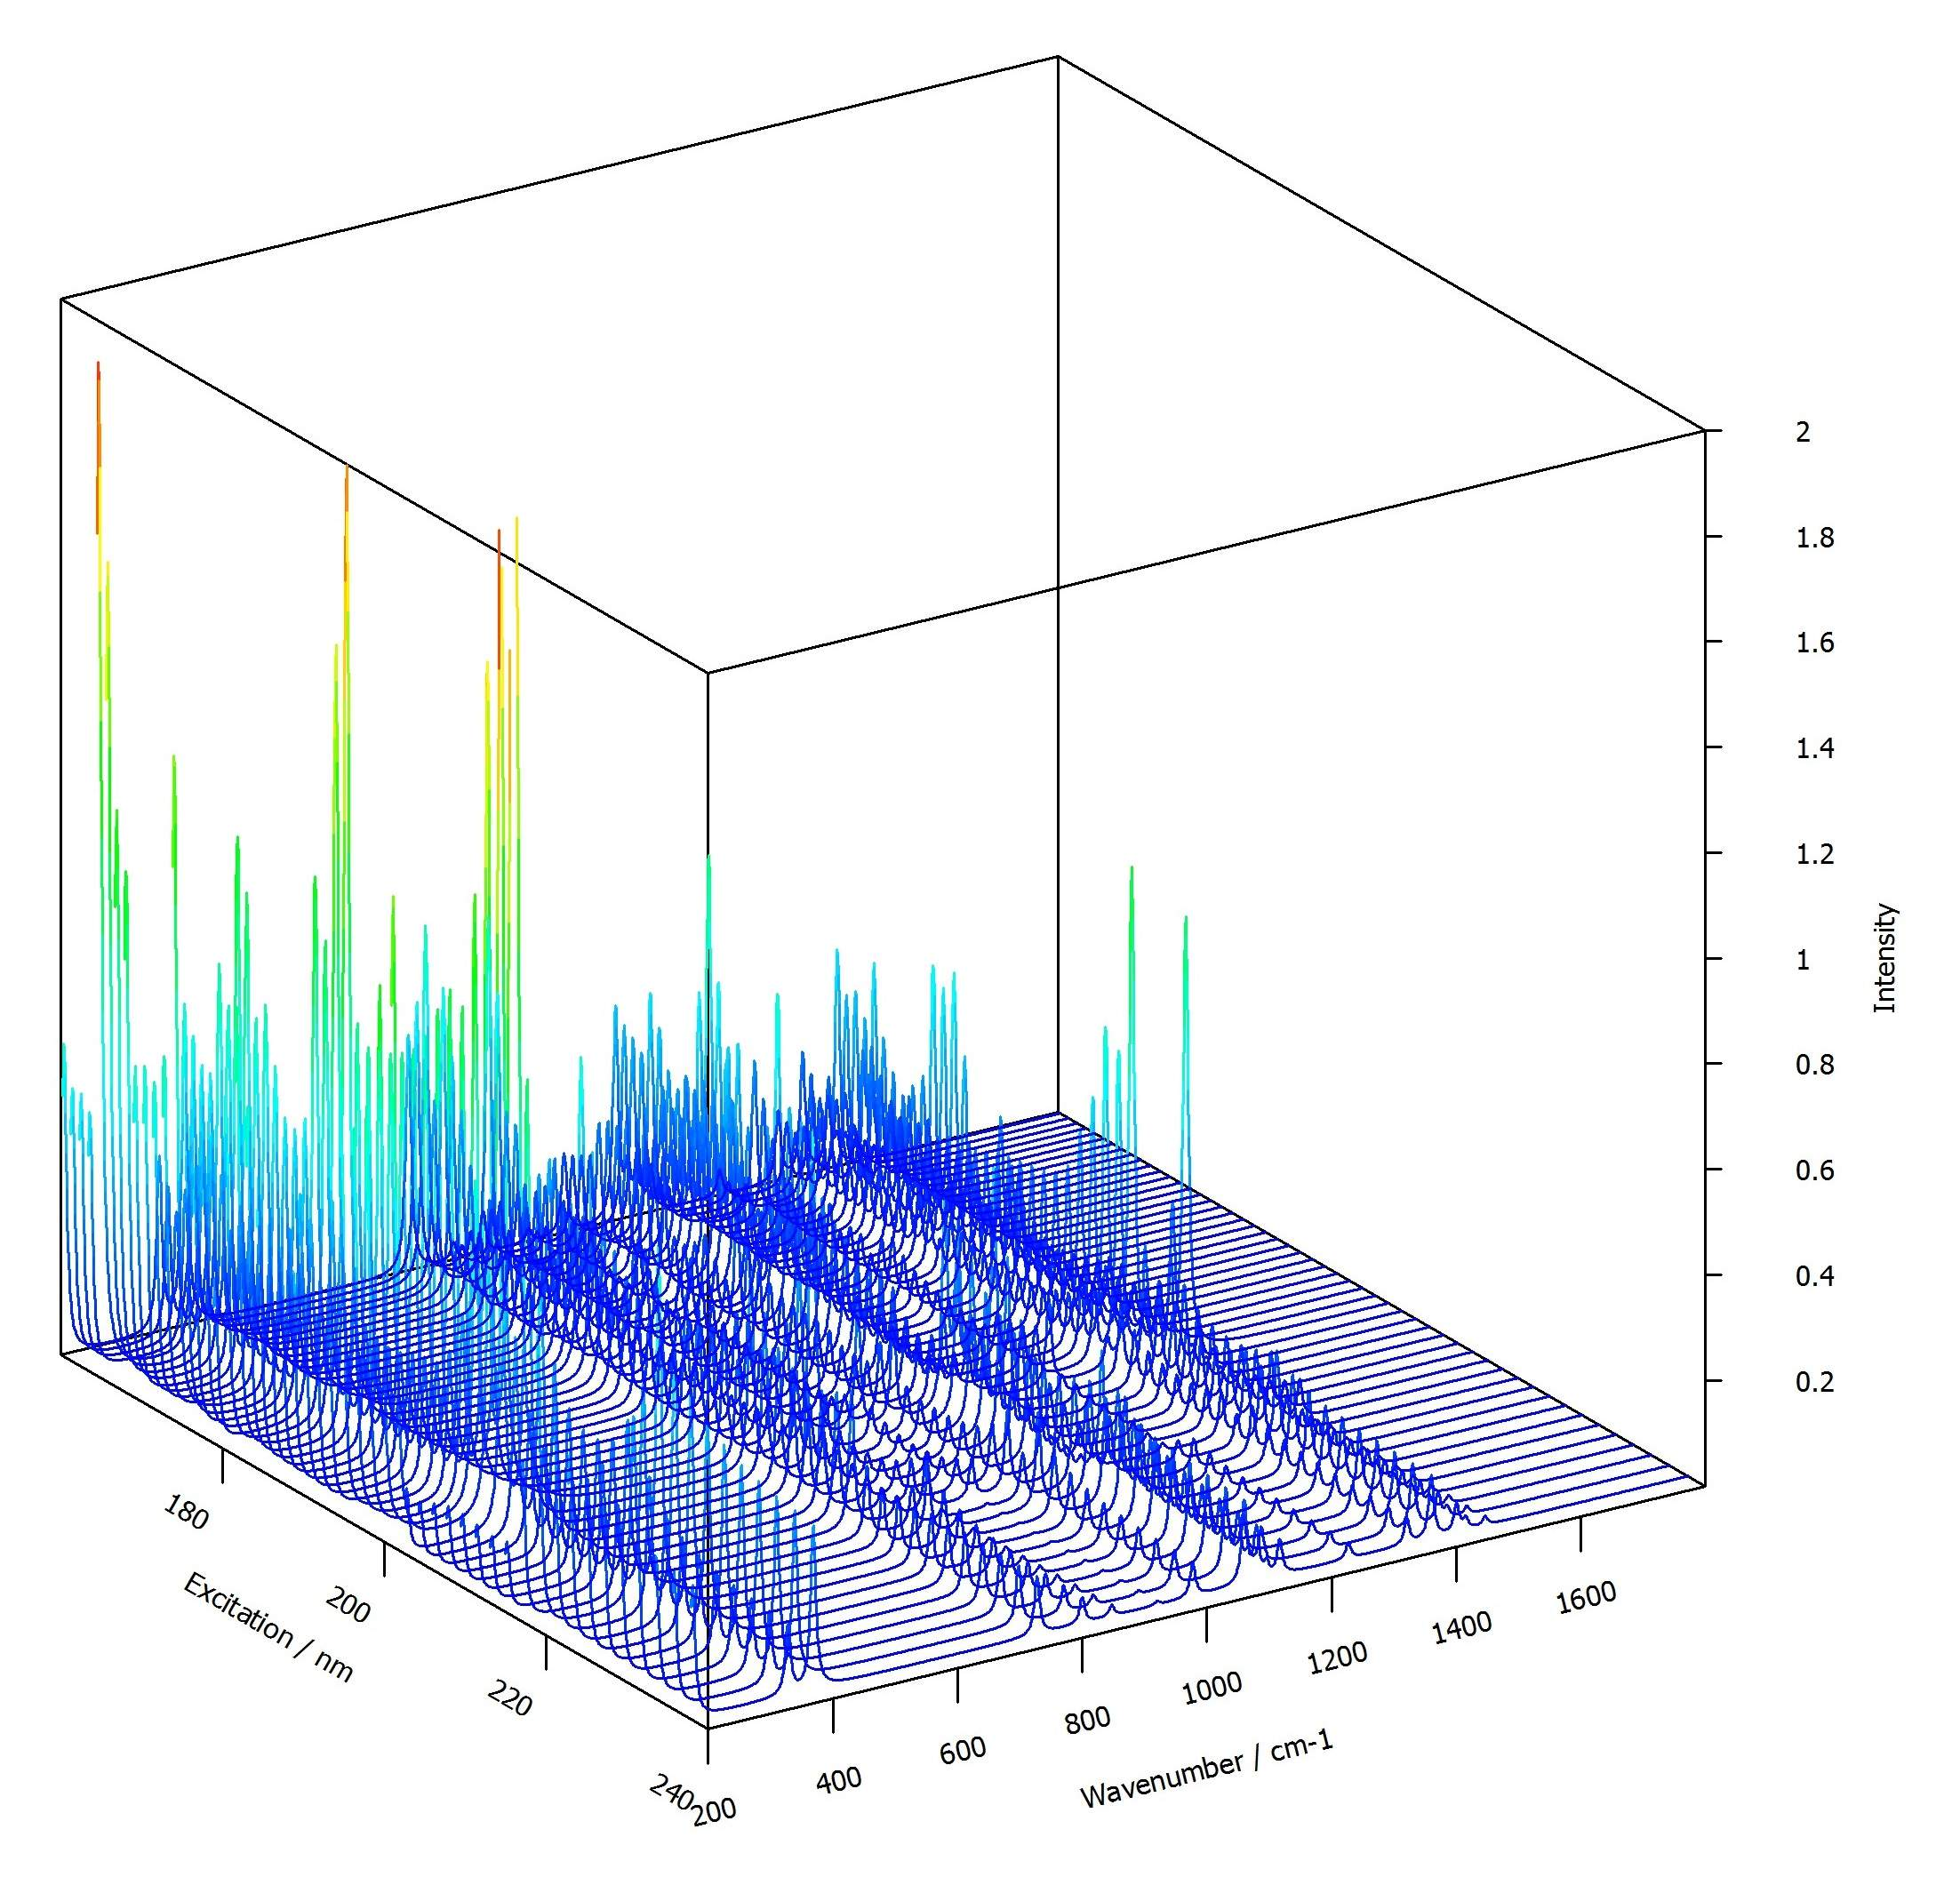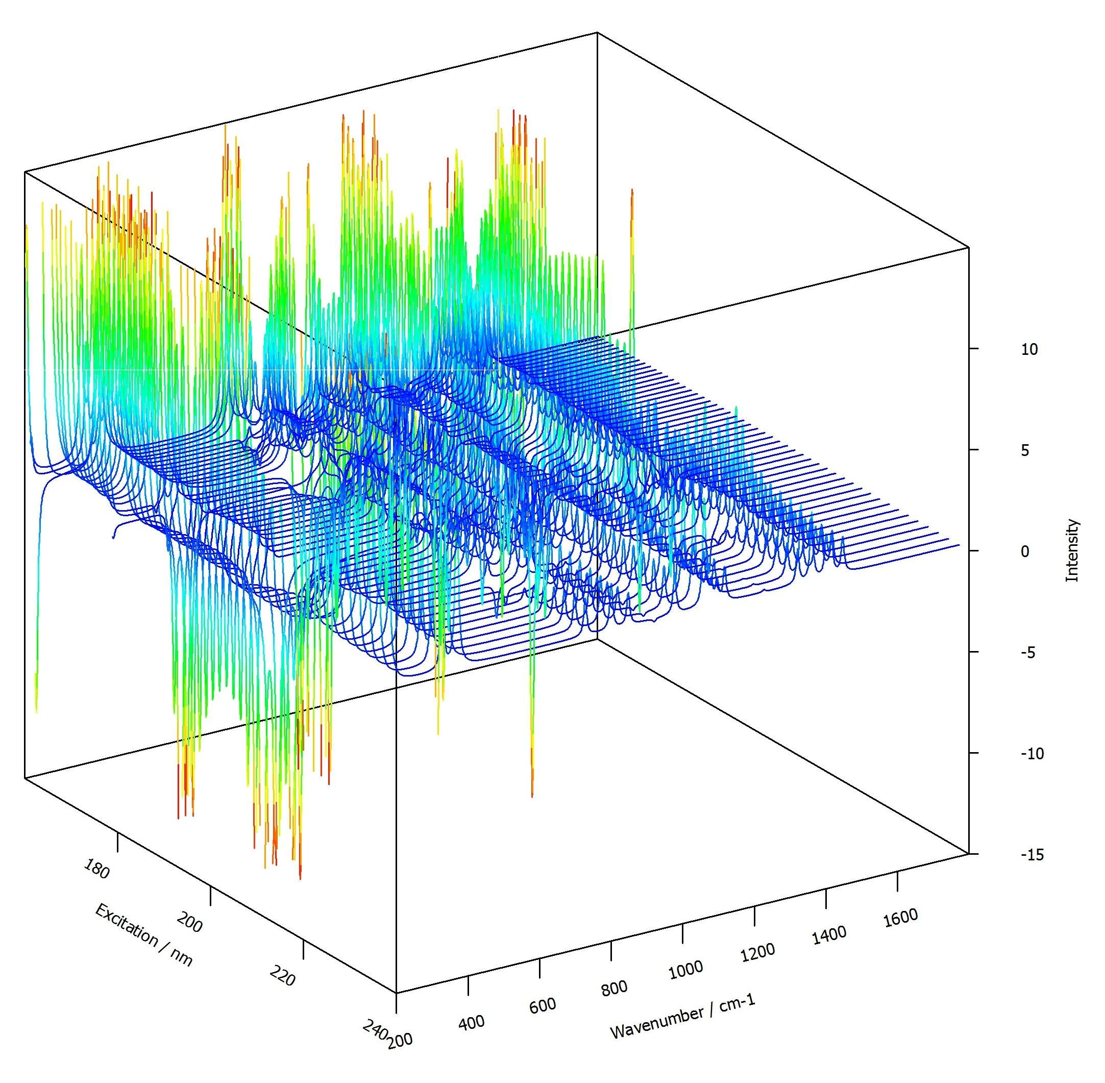

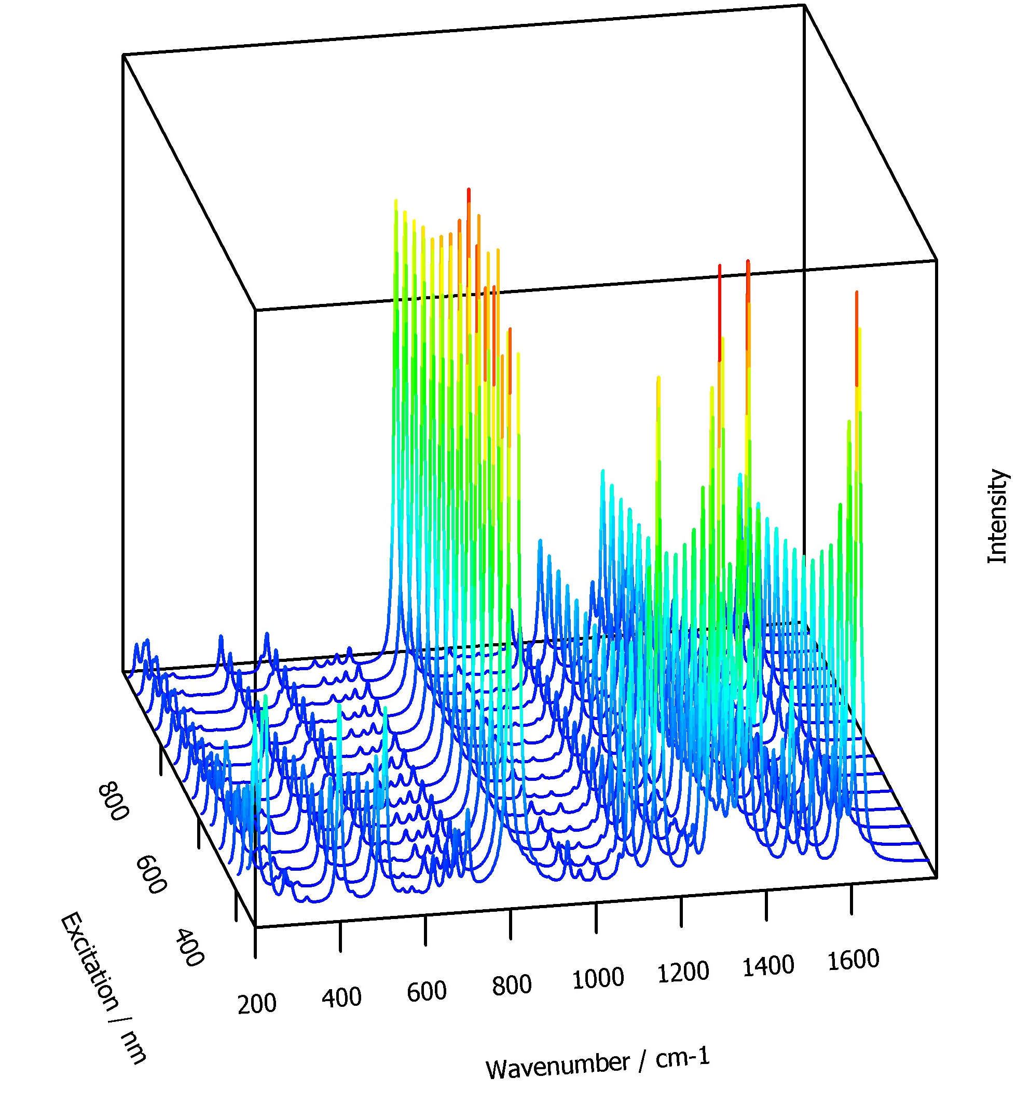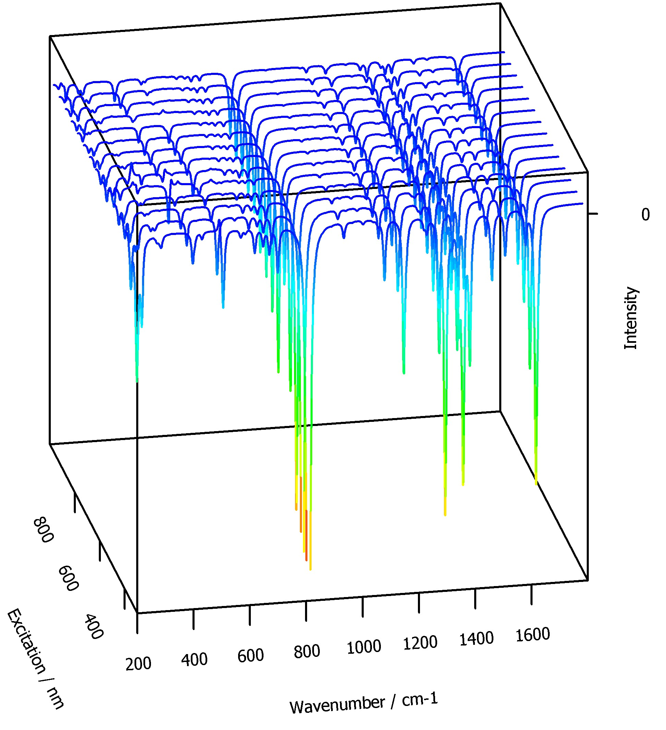
Rem
$$α_{\text{el},I,\text{αβ}}=\frac{1}{ℏ}\sum_{e≠i}{\left(\frac{μ_{0e,α}μ_{e0,β}}{ω_{e0}−ω+iΓ}+\frac{μ_{0eβ}μ_{e0α}}{ω_{e0}+ω−ω_{I}+iΓ}\right)}$$
$$=\frac{2}{ℏ}\sum_{e≠i}{μ_{0e,α}μ_{e0,β}\frac{ω_{e0}−Δ+iΓ}{(ω_{e0}−Δ+iΓ)^{2}−{\bar{ω}}^{2}}}$$
Gaussian
$$α_{G,I,\text{αβ}}=\frac{1}{ℏ}\sum_{e≠i}{\left(\frac{μ_{0e,α}μ_{e0,β}}{ω_{e0}−ω+iΓ}+\frac{μ_{0eβ}μ_{e0α}}{ω_{e0}+ω+iΓ}\right)}$$
$$α_{\text{el},I,\text{αβ}}\text{\sim }α_{G,\text{αβ}}+ω_{I}\sum_{e≠i}{\frac{μ_{0eβ}μ_{e0α}}{(ω_{e0}+ω+iΓ)^{2}}}\text{\sim }α_{G,\text{αβ}}+ω_{I}\sum_{e≠i}{\frac{μ_{0eβ}μ_{e0α}}{(ω_{e0}+ω)^{2}}}$$

Perturbation ω
$$\overset{˙}{P}(i→f)=\frac{1}{ℏ}\sum_{e≠i}{{\left|\frac{⟨i|μ_{0e,α}μ_{e0,β}|f⟩}{ω_{e0}−ω+iΓ}+\frac{⟨i|μ_{0eβ}μ_{e0α}|f⟩}{ω_{e0}+ω−ω_{\text{fi}}+iΓ}\right|}^{2}}$$
Perturbation ω’

$$\overset{˙}{P}(f→i)=\frac{1}{ℏ}\sum_{e≠i}{{\left|\frac{⟨i|μ_{0e,α}μ_{e0,β}|f⟩}{ω_{e0}−ω+ω_{\text{fi}}+iΓ}+\frac{⟨i|μ_{0eβ}μ_{e0α}|f⟩}{ω_{e0}+ω+iΓ}\right|}^{2}}$$

