mcub.f

From Gaussian output, plots electron density, electron dynamic (time-dependent, under external electric field) density, dynamic electric field.

Input: G.OUT Gaussian output, generated with options:
GFInput Pop=full iop(9/40=3) or iop(9/40=4) nosymm td
CAGE.PAR Required for cubes, cube definition
MCUB.OPT options
Output: .cub required cubes
SOS.TTT polarizability
at.txt atomic coordinates in the plane
ex,ey,ez.txt plane electric intensities
POx.TXT, POy.TXT,POz.TXT .. electric intensity of Lebedev-Laikov grid
AVx.TXT, AVy.TXT,AVz.TXT .. electric intensity on left-out atoms
MVx..., MVy...,MVz.... electric intensity on molecules

Options /default
current
lj /f dynamic current density j.cub
damp
aes/0.1 damping to ESP charge fitting
dcis
dcis / 300 nm for ncis 0 transform transition dipoles as $d'=d×\text{exp}[−(λ−x_{\text{cis}}{)^{2}}/{d_{\text{cis}}^{2}}]$
density
lro /f static density cube den2.cub
dynamic
lt /f dynamic density cube
field
le /f electric field cube
filename
ifn /G.OUT ab initio (Gaussian) output file name
gnm
gnm /0.1 nm bandwidth to avoid divergence ($Γ$)
lat
lat /t calculate intensity on atoms (with plane)
lcis
lcis / f primitive CIS from orbital energies
lleb
lleb /f Lebedev-Laikov points on surface, use in plane and potential
llog
llog /f logarithmic scale, for plane
lout
lout /f plane electric field only outside molecule
lpol
lpol /f consider electric polarizability of the molecule, from POL.TTT
lzmat
lzmat /t Z-matrix orientation
ld5,lf7,lg9,lh11,li13 (f/f/f/f/f) use spherical AOs, d,f,g,h,i orbitals
ld5,lf7,lg9,lh11,li13 (f/f/f/f/f)
pcurrent
ljp /f dynamic current density in plane j.cub
mo1
mo1/0 from which occupied orbital to start CIS, use one for mo1 = 0.
mo2
mo2/0 at which virtual orbital to end CIS, use all for mo1 = 0.
ncis
ncis / 0 for ncis 0 transform wavelengths as $λ'=x_{\text{cis}}(λ/{x_{\text{cis}}})^{n_{\text{cis}}}$
nnm
nnm / 1 number of excitation frequencies (should precede wnm)
npoint
np/10 number of points for polarizability
nproc
nproc /0 number of processors (for plane only so far)
nleb
nleb /62 number of Lebedev-Laikov points
nlim
nlim /0 limit of involved atoms for plane, 0 for all
nmol
nmol /0 if nmol 0 calculate intensity in molecular centers, nmol is then number of atoms in one molecule (nlim first atoms are ignored)
pcurrent
lj /f dynamic current density in plane
plane
lb /f plot electric field plane section,
P0x P0y P0z /0 0 0 plane origin / A
N1 v1x v1y v1z /0 0 0 0 number of repeats, first plane vector
N2 v2x v2y v2z /0 0 0 0 number of repeats, second plane vector
potential
lfi /f plot electrictrostatic potential in pot2.cub cube
qtot
qt /0 plot total charge for potential
rleb
rleb /5 Å radius of Lebedev-Laikov spheres
wnm
w₁ ... w_{nnm} /532 ... nm excitation frequencies (), if nnm>1, nnm should precede
wcis
wcis / 0 nm for wcis 0 limit excitation wavelengths by this value
wmax
wmax /500 nm
wmin
wmin /150 nm
xcis
xcis / 600 nm for ncis 0 transform transition dipoles as $d'=d×\text{exp}[−(λ−x_{\text{cis}}{)^{2}}/{d_{\text{cis}}^{2}}]$

Remark:PM7 calculation of static potential (lfi)
The Gaussian wavefunction is inaccurate, and relativistic metals are not recognized by mcub.
Therefore file Q.LST is needed, where on line effective atomic charges are listed. For gold, the PM7 effective charge is 11 in PM7, for example. Also, lcis option is recommended, because it invokes computation of AO overlap matrix in SAO.SCR. When this is present, the wavefunction (orbitals) is renormalized.

Example of MCUB.OPT:
plane plane section
t
-6 -4 0 plane origin at r = (-6,-5,0)Å
48 0.25 0 0 48 propagate vector (0.25,0,0)Å

32 0.0 0.25 0 32 propagate vector (0,0.25,0)Å (grid of 4832 points)
ld5 spherical d-orbitals
t
lf7 spherical f-orbitals
t
lout set zero inside molecule
t
llog logarithmic scale
t
nproc use two processors for parallel run
2

Example of CAGE.PAR
-2 -5.500000 -4.000000 -2.500000 Nat, cube origin in bohrs
44 0.250000 0.000000 0.000000 44 propagate vector (0.25,0,0) bohr, etc
32 0.000000 0.250000 0.000000
20 0.000000 0.000000 0.250000

Polarizability
$$α_{\text{αβ}}(R)\text{\sim }\frac{1}{ℏ}\sum_{e}{\frac{(ω_{\text{en}}−ω−iΓ)}{(ω_{\text{en}}−ω)^{2}+Γ^{2}}μ_{\text{ne},α}μ_{\text{en},β}}$$

Static density
$ρ_{0}=e\int{ϕ_{0}^{}ϕ_{0}}$, $ϕ_{0}$ .. Ground state Slater determinant, integral over all electrons except one
Closed shell
$ρ_{0}(r)=2e\sum_{i,\text{occ}}{ψ_{i}^{}}(r)ψ_{i}(r)$, $ψ_{i}(r)$ ... molecular orbital
$ψ_{i}(r)=\sum_{a}{C_{i,b}χ_{a}(r)}$, $χ_{a}(r)(r)$ ... atomic orbital, $C_{i,b}$ .. orbital coefficients

Dynamic density
Perturbation: $V(t)=V_{0^{}}e^{iωt}+V_{0}e^{−iωt}$, $V_{0}=−μ⋅E_{0}$,  ... dipole moment operator, E₀ .. amplitude of electric field of the light
$ρ(r,t)=\frac{2e}{ℏ}\sum_{n}{\frac{V_{n0}\text{cos}(ωt)}{ω−ω_{n0}}}\int{ϕ_{n}^{}ϕ_{0}}$, sum over excited states, integral over all electrons except one, $V_{\text{mi}}=⟨ϕ_{m}|V_{0}|ϕ_{i}⟩$
$$ρ(r,t)=−\frac{2e}{ℏ}E_{0}⋅\sum_{a,b}{d_{\text{ab}}χ_{a}(r)χ_{b}(r)}\text{cos}(ωt)$$
$d_{\text{ab}}=\sum_{n}{\frac{μ_{0n}(ω−ω_{n0}−iΓ)}{(ω−ω_{n0})^{2}+Γ^{2}}}\sum_{i}{c_{i}^{n}}C_{\text{ai},a}C_{\text{bi},b}$, $μ_{0n}=⟨ϕ_{0}(0)|μ|ϕ_{n}(0)⟩$, $c_{i}^{n}$ .. CI coefficients
For each $E_{0}=(1,0,0),(0,1,0),(0,0,1)$ plot $ρ^{}(0)ρ(0)=[\text{Re}(ρ^{}(0))]^{2}+[\text{Im}(ρ(0))]^{2}$ to files denx.cub, deny.cub, denz.cub
Dynamic current density
$$j(r,t)\text{\sim }E_{0}⋅\sum_{a,b}{d_{\text{ab}}χ_{a}(r)∇χ_{b}(r)}\text{sin}(ωt)$$

Static Potential
$$ϕ(R)=ϕ_{e}(R)+ϕ_{n}(R)$$
$$ϕ_{n}(R)=\sum_{λ}{\frac{Z_{λ}}{|R−r_{λ}|}}$$
$$ϕ_{e}(R)=−\frac{2}{4{\text{πε}}_{0}}\int{\sum_{i,\text{occ}}{\frac{ψ_{i}^{2}(r)}{|R−r|}}dr}=−\frac{1}{4{\text{πε}}_{0}}\sum_{a,b}{D_{\text{ab}}\int{\frac{χ_{a}(r)χ_{b}(r)}{|R−r|}}}dr$$
$$D_{\text{ab}}=2\sum_{i,\text{occ}}{c_{\text{ia}}c_{\text{ib}}}$$
$$\int{\frac{χ_{a}(r)χ_{b}(r)}{|R−r|}}dr=\int{\frac{χ_{a}χ_{b}(r)}{|r'−r|}δ(R−r')}drdr'={\left(\frac{δ}{π}\right)}^{\frac{3}{2}}\int{\frac{χ_{a}χ_{b}(r)}{|r'−r|}e^{−δ(r'−R)^{2}}e^{−δ(r'−R)^{2}}}drdr'|_{δ→∞,γ→0}$$
$$={\left(\frac{δ}{π}\right)}^{\frac{3}{2}}(\text{abcd})$$
Electric field intensity of a molecule
For small distances $E(t)=−∇ϕ−\overset{˙}{A}\text{\sim }\frac{1}{4{\text{πε}}_{0}}\int{\frac{ρ(r,t)(R−r)}{|R−r|^{3}}dr}$
$$=−2\frac{{eE}_{0}⋅}{4ℏ{\text{πε}}_{0}}\sum_{a,b}{d_{\text{ab}}\int{χ_{a}(r)χ_{b}(r)\frac{(R−r)}{|R−r|^{3}}dr}\text{cos}(ωt)}$$
For each $E_{0}=(1,0,0),(0,1,0),(0,0,1)$ plot $I=[E_{x}^{}(0)E_{x}(0)+E_{y}^{}(0)E_{y}(0)+E_{z}^{}(0)E_{z}(0)]/{E_{0}^{2}}$ to files ex.txt, ey.txt, ez.txt (plane) or ex.cub, ey.cub, ez.cub (cubes)

How to calculate the integral
$$\int{χ_{a}(r)χ_{b}(r)\frac{(R−r)}{|R−r|^{3}}dr}=−\frac{∂}{∂R}\int{χ_{a}(r)χ_{b}(r)\frac{1}{|R−r|}dr}$$
$$=−\frac{∂}{∂R}\int{χ_{a}(r)χ_{b}(r)\frac{1}{|r'−r|}δ(r'−R)dr}dr'$$
$$=−\frac{∂}{∂R}{\left(\frac{δ}{π}\right)}^{\frac{3}{2}}\int{χ_{a}(r)χ_{b}(r)\frac{1}{|r'−r|}e^{−γr'^{2}}e^{−δ(r'−R)^{2}}dr}dr'=−{\left(\frac{δ}{π}\right)}^{\frac{3}{2}}\frac{∂(\text{abcd})}{∂R}$$
$$=−2δ{\left(\frac{δ}{π}\right)}^{\frac{3}{2}}\int{χ_{a}(r)χ_{b}(r)\frac{1}{|r'−r|}e^{−γr'^{2}}(r'−R)e^{−δ(r'−R)^{2}}dr}dr'=−2\sqrt{\frac{δ^{5}}{π^{3}}}(\text{abcp})$$

$γ→0$, $δ→∞$, $(\text{abcp})$ is the usual two-electron integral of four Gaussian “atomic orbitals”

CIS from orbital energies
Designed for the Hückel method:
Ground state: energy (closed shell): $E_{0}=2\sum_{i,\text{occ}}{e_{i}}$, wave function $ψ=Δ$, e_{i} are the orbitals energies,  is Slater determinant.
Excited states: $E_{n(\text{ab})}=E_{0}+e_{b}−e_{a}$$ψ_{n(\text{ab})}=Δ_{n(\text{ab})}$, $Δ_{n(\text{ab})}$ is  where one electron is moved from occupied orbital a to virtual orbital b

Electrostatic potential charge fitting
1) Calculate potential _{i} in Nsp points around the molecule
2) Find charges q_{a} in N_{r} atoms that minimize
$σ=\sum_{i}{(ϕ_{i}}−\sum_{a}{\frac{q_{a}}{|r_{a}−r_{i}|}})^{2}+α\sum_{a}{q_{a}^{2}}$
$\sum_{a}{q_{a}=Q}$
$$−\sum_{i}{(ϕ_{i}}−\sum_{a}{\frac{q_{a}}{|r_{a}−r_{i}|}})\frac{1}{|r_{k}−r_{i}|}+{αq}_{k}=−λ$$

$$\sum_{a}{\sum_{i}{\frac{1}{|r_{a}−r_{i}|}}}\frac{1}{|r_{k}−r_{i}|}q_{a}+{αq}_{k}+λ=\sum_{i}{ϕ_{i}}\frac{1}{|r_{k}−r_{i}|}$$
$M_{\text{ak}}=\sum_{i}{\frac{1}{|r_{a}−r_{i}|}\frac{1}{|r_{k}−r_{i}|}+{\text{αδ}}_{\text{ak}}}$, $v_{k}=\sum_{i}{ϕ_{i}}\frac{1}{|r_{k}−r_{i}|}$
$\left(\begin{matrix}M & 1 \\ 1 & 0\end{matrix}\right)\left(\begin{matrix}q \\ λ\end{matrix}\right)=\left(\begin{matrix}v \\ Q\end{matrix}\right)$, $\left(\begin{matrix}q \\ λ\end{matrix}\right)={\left(\begin{matrix}M & 1 \\ 1 & 0\end{matrix}\right)}^{−1}\left(\begin{matrix}v \\ Q\end{matrix}\right)$
Examples
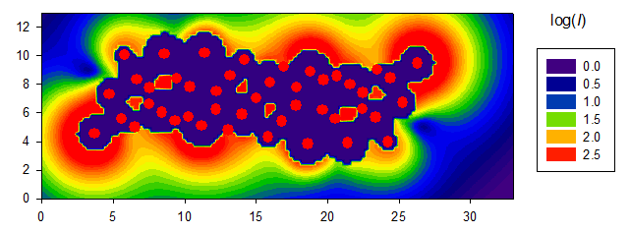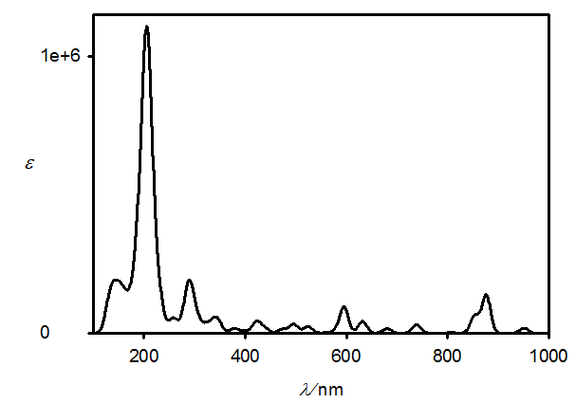
Calculated (PM7) electric field intensity around Au₄₆ cluster, excitation polarization along x, _{exc} (= ) = 205 nm,  = 0.5 nm, and the absorption spectrum.
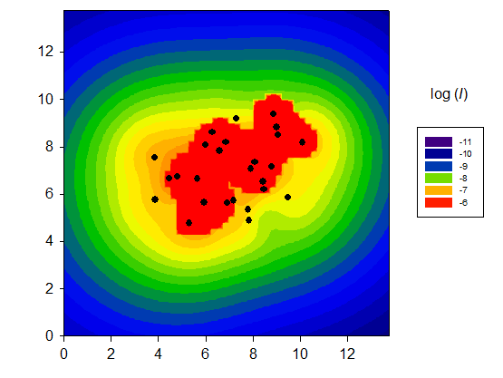
Calculated (B3LYP/6-31G*, from excited 100 states) electric field intensity around -pinene, excitation polarization along x, _{exc} = 532 nm,  = 5 nm.

